Project Flow
Frontend → IPFS (employee photo)
↓
MetaMask → Sepolia → Solidity contract
↓
Employee data + IPFS CID stored on public blockchain
Sepolia is an Ethereum public testnet, so this lets you experiment with a real public blockchain without using real ETH. Ethereum currently describes Sepolia as a maintained public test chain, although it also notes that Hoodi is the recommended long-term-support testnet.
Pinata
Pinata for the IPFS experiment gives a relatively straightforward way to upload files and obtain a CID. Its current SDK supports public file uploads and gateway retrieval.
Step 1 — Create a Pinata account
Go to the official Pinata site:
https://www.pinata.cloud
Create a Pinata API Key
- Click API Keys on the left.
- Click New Key.
- For the first experiment, we can use Admin access. Pinata itself recommends this for getting started; later we can restrict the permissions.
- Give it a name such as:
Employee-DApp
- Keep usage as unlimited for this experiment.
- Click Create Key.
You should then see something similar to:
- pinata_api_key
- pinata_api_secret_key
- JWT
Very important: copy/save the JWT immediately. Pinata says the secret/JWT is shown only once.
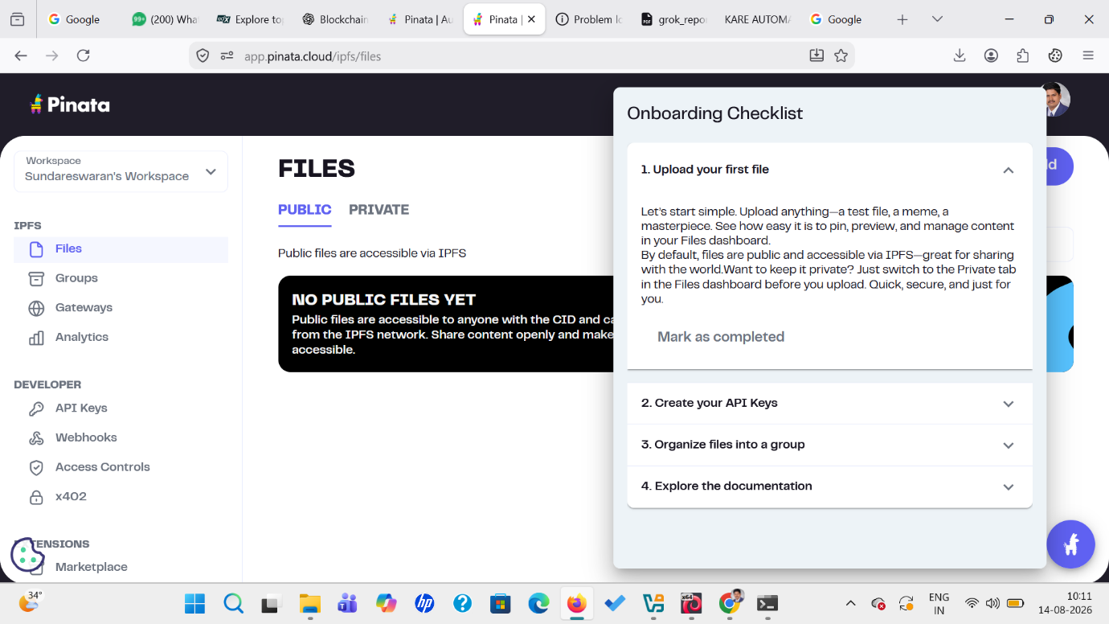

Create an account and open the dashboard, For your first experiment, upload: filename.jpg
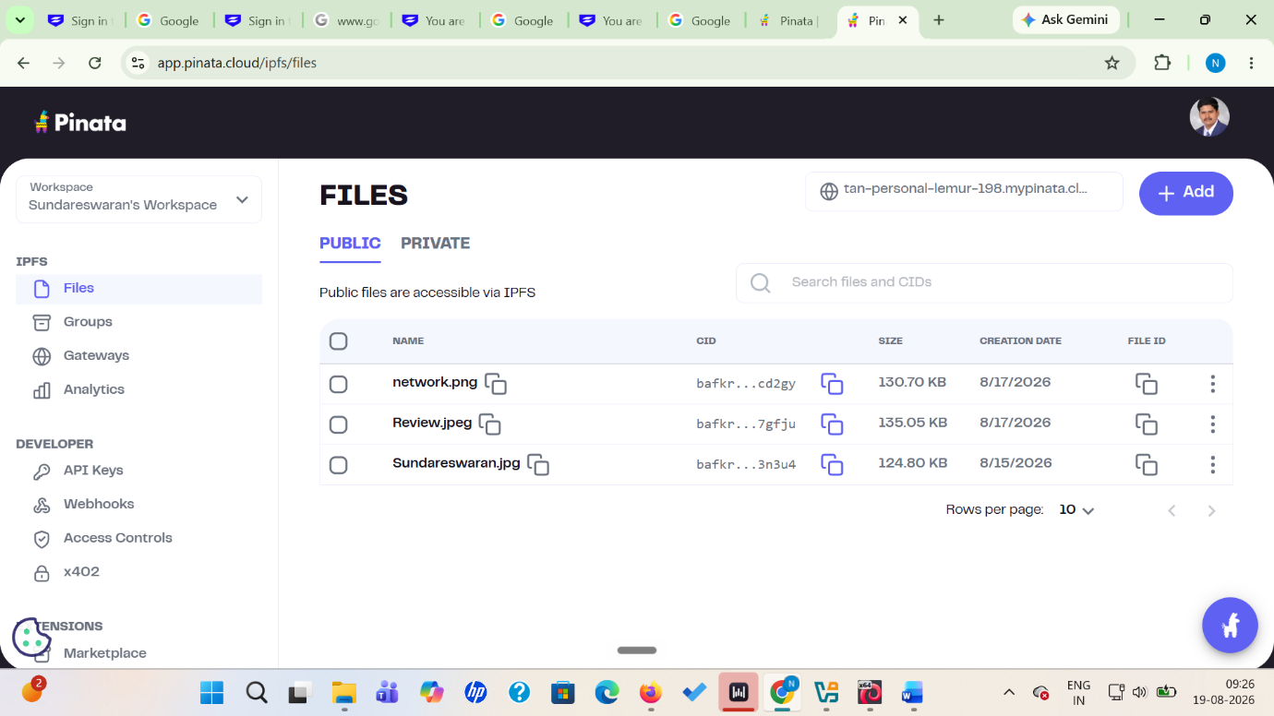

Pinata will provide a CID similar to: bafybeihxxxxxxxxxxxxxxxxxxxxxxxx as shown.
Backend operations
Open the terminal inside VS Code.
Move into the new folder:
cd "path-to-your-Employee-Management-DApp\pinata-backend"
cd "C:\Users\YourName\Documents\Applied Blockchain\Employee Management DApp\pinata-backend"
Then initialize Node:
npm init -y
Install the required packages
Run:
npm install express multer dotenv cors pinata
npm i pinata
The other packages are for our small upload server:
- express → backend server
- multer → receive the uploaded image
- dotenv → safely read the JWT from .env
- cors → allow your frontend to communicate with the backend
- pinata → Pinata SDK
Create .env
Inside:
pinata-backend
create:
.env
Put your Pinata API credential in it.
PINATA_JWT=PASTE_YOUR_PINATA_JWT_HERE
Also create:
.gitignore
and put:
.env
node_modules/
inside it.
This prevents you from accidentally publishing your JWT to GitHub later.
Create server.js
Inside pinata-backend, create:
server.js //paste-code
In the terminal, make sure you are inside:
pinata-backend
Then run:
node server.js
You should see:
Pinata backend running at:
http://localhost:3000
Open another terminal and Run (cmd prompt)
curl -X POST -F "file=@..\Employee Management DApp\image\filename.jpg" http://localhost:3000/upload

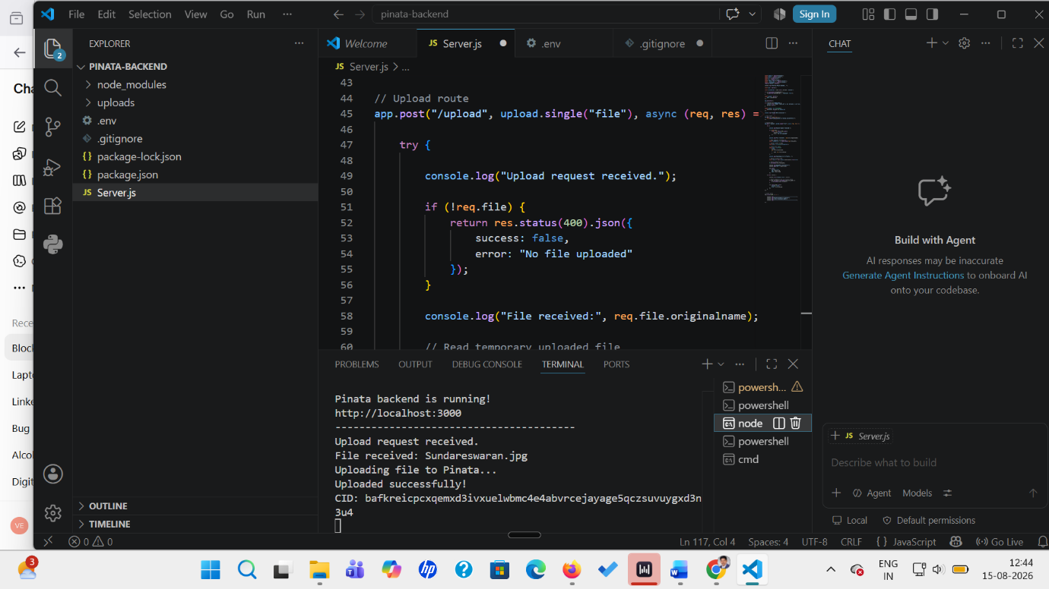
verify the image through IPFS
https://ipfs.io/ipfs/YOUR_CID
Deploy to Sepolia - Sepolia ETH is also test ETH, not real money. It is specifically intended for development/testing.
Now we move from Ganache to Sepolia.
In MetaMask, Enable test networks (Go to:
Networks → Show test networks)
Turn Show test networks = ON.
Click the Networks/dropdown.
select:
Sepolia
You will need Sepolia test ETH for deployment and transactions.
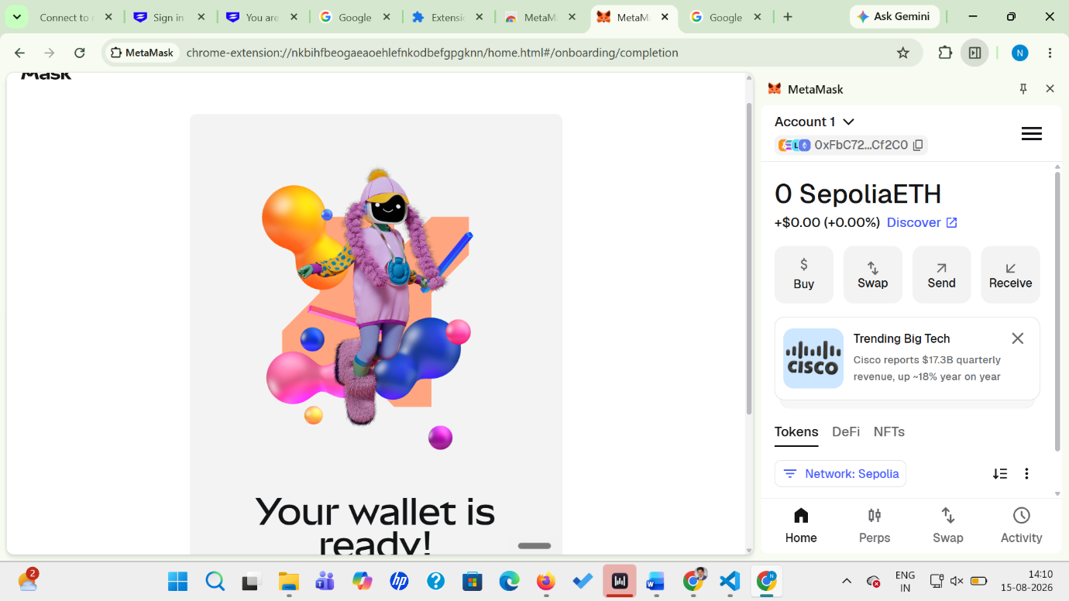
Copy your MetaMask address your address is displayed near the top:
0xFbC72...Cf2C0
Click the copy icon next to the address.
Then Go to: https://cloud.google.com/application/web3/faucet/ethereum/sepolia
f that faucet asks you to sign in, use your Google account and enter your MetaMask public address.
Your address is safe to enter into a faucet because it is a public wallet address.
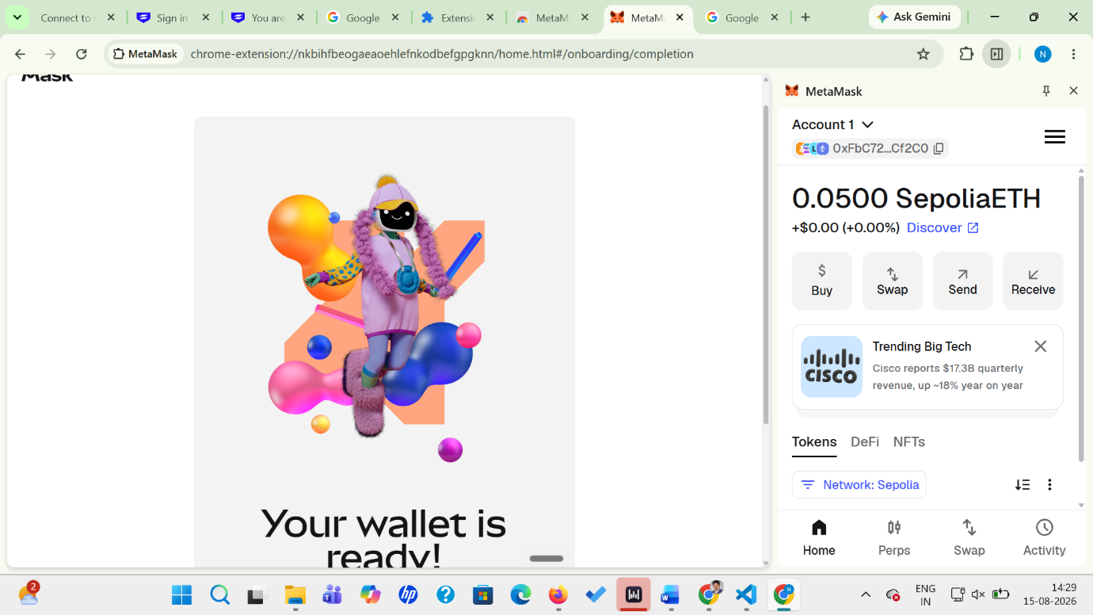
Next try: Go to A good option is the Alchemy Sepolia Faucet.
https://www.alchemy.com/faucets/ethereum-sepolia
or https://sepoliafaucet.com
Contract Deployment
Open your Solidity contract
Run the code (Compile and Deploy on Sepolia-Metamask)
Use the Remix to test it (by entering values to the fields).
Front End:
Frontend:
http://127.0.0.1:5500
Backend:
http://localhost:3000
In the pinata-backend CMD terminal, run:
npm install cors
(Copy-paste front end files) Run Go Live Successfully
Check backend before that
Open CMD, not PowerShell:
Go to the exact link where cd "C:\Blockchain Skill\Sepolia Employee DAPP\pinata-backend" (for example)
Then: node Server.js
Test: on another cmd terminal
curl http://localhost:3000
Expected:
Pinata backend is running successfully.
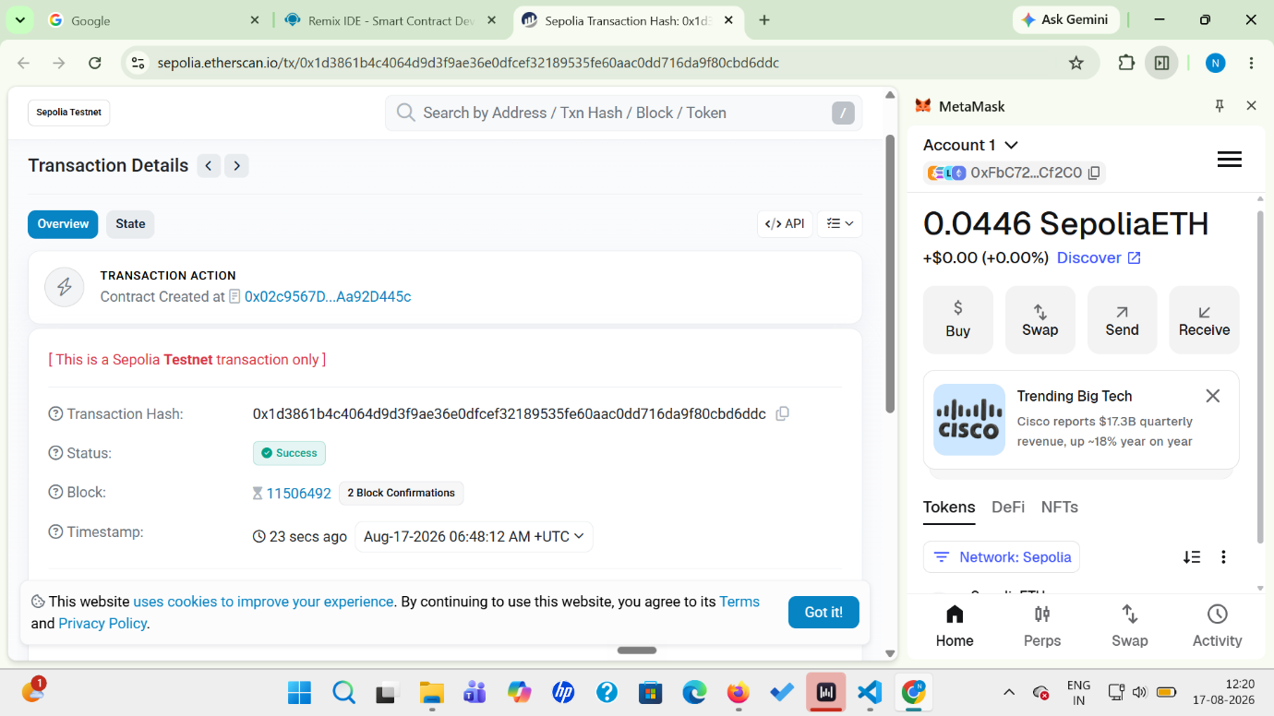

the contract address shown in the screenshot is the address we must put into your frontend. We should verify the full address before pasting it into contract.js/app.js, rather than relying on the shortened Etherscan display.
your frontend and test the complete flow:
- Open index.html.
- Connect MetaMask.
- Confirm that MetaMask is on Sepolia.
- Enter employee details.
- Select the employee photograph.
- Click Register Employee.
- Frontend uploads the photograph to your Pinata backend.
- Pinata returns the CID.
- Frontend calls registerEmployee() on your already deployed Sepolia contract.
- MetaMask asks you to confirm the transaction.
- After confirmation, the employee record is stored on Sepolia with the IPFS CID.
- Then use Get Employee to retrieve the record and display the photograph.
I would emphasize Sepolia + Solidity + MetaMask + IPFS/Pinata + Node.js backend + frontend integration and the actual workflow demonstrated.

